Linked In!

Objectives

Connect devices using wired and wireless media.

In this activity, you will map your network cabling or technology type ideas to a physical topology. Because this chapter focuses on the network access layer, you should be able to prepare a basic physical model. No logical (IP addressing) schemes are required for this activity.

Physical Topology

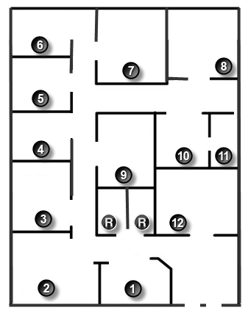

Background/Scenario

**Note**: This activity is best completed in groups of 2-3 students.

Your small business is moving to a new location! Your building is brand new and you must come up with a physical topology so that network port installation can begin.

Your instructor will provide you with a blueprint created for this activity. The area on the blueprint, indicated by Number 1, is the reception area and the area labeled “RR” is the restroom area.

All rooms are within Category 6 UTP specifications (328 ft. [100 m]), so you have no concerns about hard-wiring the building to code. Each room in the diagram must have at least one network connection available for users/intermediary devices.

With your teammate(s), indicate on the drawing:

* + Where would you locate your network main distribution facility, while keeping security in mind?
  + How many intermediary devices would you use and where would you place them?
  + What kind of cabling you would use (UTP, STP, wireless, fiber optics, etc.) and where would the ports be placed?
  + What types of end devices you would use (wired, wireless, laptops, desktops, tablets, etc.)?

Do not go into excessive detail on your design. Just use the content from the chapter to be able to justify your decisions to the class.

Required Resources

Packet Tracer software

Reflection

1. Where would you locate your network main distribution facility, while keeping security in mind?

____________________________________________________________________________________

____________________________________________________________________________________

____________________________________________________________________________________

1. How many intermediary devices would you use and where would you place them?

____________________________________________________________________________________

____________________________________________________________________________________

____________________________________________________________________________________

1. What kind of cabling you would use (UTP, STP, wireless, fiber optics, etc.) and where would the ports be placed?

____________________________________________________________________________________

____________________________________________________________________________________

____________________________________________________________________________________

____________________________________________________________________________________

1. What types of end devices you would use (wired, wireless, laptops, desktops, tablets, etc.)?

____________________________________________________________________________________

____________________________________________________________________________________

____________________________________________________________________________________